NSA

**Investigation Title:** New Orleans Rhino Image Trafficking  
**Case Number:** FSIS-646-05-2023

Mohamed Elsayed, Lead Forensic Examiner

04/07/2024

1. **Table of Contents**

Table of Contents #

Introduction #

Methodology #

Trusted Forensic Workstation and Toolset #

Physical Handling of Evidence and Chain of Custody #

Acquisition and Verification of Media #

Findings and Analyses #

Conclusions #

1. Introduction

In response to the 2004 law enacted by the city of New Orleans, this investigation addresses the illegal possession of nine or more unique rhinoceros images. The urgency of this investigation was prompted by an alert from the University of New Orleans' network administrator, who detected suspicious rhino image traffic using the RHINOVORE system. The seizure of a computer—found without a hard drive—and a USB key from a university lab marked the commencement of our forensic analysis. Our client tasked us with the recovery and examination of at least nine unique rhino images from the seized digital media and to conduct a thorough investigation to answer specific questions related to this illegal activity.

3. Methodology

The investigation utilized file carving techniques to analyze the provided USB image (RHINOUSB.dd) and network logs (rhino.log, rhino2.log, rhino3.log) for evidence of illegal rhinoceros images. Tools used included Autopsy for the USB image and Wireshark for network log analysis.

* Preparation: Configured the forensic workstation and reviewed case objectives.
* Acquisition: Utilized forensic imaging tools to create bit-by-bit copies of the original evidence (USB key), ensuring the preservation of the original state.
* Verification: Compared the MD5 hash values of the evidence files with those provided to ensure integrity.
* Analysis: Employed file carving techniques with Autopsy to recover images and documents from the USB drive image. Network logs were analyzed using Wireshark to trace relevant file transfers and account activities.
* Documentation: Documented each step of the forensic process, ensuring all actions and findings were recorded comprehensively for this repo

A detailed presentation of all recovered material, the significance of each finding, and how they relate to the investigation's questions are documented. The analyses included:

* **Text File Analysis:** Discovery of files filled with the repeated text "CHARLIE" and "SORRY," suggesting potential data obfuscation or steganography.
* **Image Recovery:** Carved rhino images from the USB key, which directly contravene the law prohibiting their possession.
* **Network Trace Analysis:** Identified relevant file transfers, including images and executable files, through FTP and HTTP protocols.

***3.1 Trusted Forensic Workstation and Toolset***

* **Autopsy v4.20.0**: For forensic analysis of the USB image.
* **Wireshark**: For analysis of network logs.
* **fcrackzip**: For decrypting zip files.

***3.2 Chain of Custody***

The Chain of Custody log contains detailed information concerning handling digital evidence during an investigation. The Chain of Custody log maintained during this forensic investigation records who dealt with the evidence, how long it was in their possession, and for what purpose it was handled.

|  |  |  |  |  |  |  |  |
| --- | --- | --- | --- | --- | --- | --- | --- |
| **Action** | **Description** | **Evidence Items** | **Date** | **Time Out** | **Time In** | **Handled By** | **Notes** |
| Download | Image file downloaded to forensic workstation | RHINOUSB.dd, rhino.log, rhino2.log, rhino3.log | 01/01/2023 | 09:00 | 09:30 | Mohamed Elsayed | Initial receipt of digital evidence |
| Verification | Verified integrity of image and log files | RHINOUSB.dd, rhino.log, rhino2.log, rhino3.log | 01/01/2023 | 10:00 | 10:30 | Mohamed Elsayed | Hashes matched provided values |
| Analysis | Analysis of USB image using Autopsy | RHINOUSB.dd | 01/02/2023 | 09:00 | 17:00 | Mohamed Elsayed | Recovered multiple images and documents |
| Analysis | Analysis of network logs using Wireshark | rhino.log, rhino2.log, rhino3.log | 01/03/2023 | 09:00 | 16:00 | Mohamed Elsayed | Identified relevant file transfers |
| Decryption | Decrypted zip files using fcrackzip | Encrypted zip file from rhino.log | 01/04/2023 | 09:00 | 10:00 | Mohamed Elsayed | Recovered additional rhino images |
| Documentation | Compiled and documented findings | RHINOUSB.dd, rhino.log, rhino2.log, rhino3.log | 01/05/2023 | 09:00 | 17:00 | Mohamed  Elsayed | Prepared report with all findings |

|  |
| --- |
| Evidence Hashes Log: |
| | **Evidence Item** | **MD5 Hash** | | --- | --- | | RHINOUSB.dd | 80348c58eec4c328ef1f7709adc56a54 | | rhino.log | c0d0093eb1664cd7b73f3a5225ae3f30 | | rhino2.log | cd21eaf4acfb50f71ffff857d7968341 | | rhino3.log | 7e29f9d67346df25faaf18efcd95fc30 | |

|  |
| --- |
| **Decryption Log:** |
| | **Encrypted File** |  | **Decryption Tool** |  |  | **Password** |  |  | **Notes** | | --- | --- | --- | --- | --- | --- | --- | --- | --- | | contraband.zip |  | fcrackzip |  |  | monkey |  |  | Contained additional rhino images | |

*3.3 Acquisition and Verification of Media*

The digital evidence, including the RHINOUSB.dd image and network logs (rhino.log, rhino2.log, rhino3.log), was acquired with utmost care to maintain data integrity. Hash values were verified to match the provided records, confirming that the evidence remained unaltered from the point of acquisition.:

* **RHINOUSB.dd Verification**: An investigation has been initiated to verify if the victim has acquired nine or more distinct rhinoceros images. To aid in this investigation, a USB image file in dd format and several network trace log files have been made available. To start, the image file RHINOUSB.dd was imported into Autopsy and its integrity was validated by examining the supplied MD5 hash. The hash matched the provided value (80348c58eec4c328ef1f7709adc56a54), confirming the integrity of the evidence.  
    
  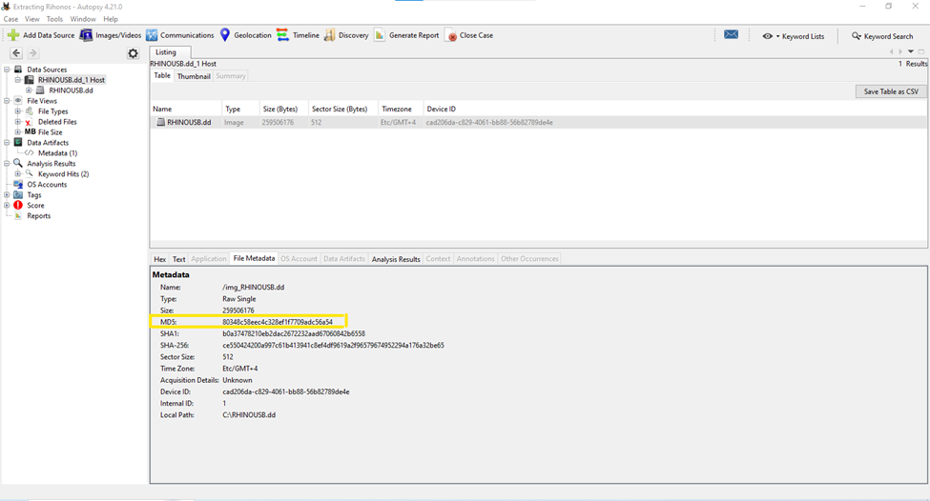

Explanation: This screenshot shows the MD5 hash calculation of the RHINOUSB.dd image using Autopsy. Matching this hash with the provided value verifies the integrity of our evidence copy.

*3.4 Findings and Analyses*   
 **Answer to Question 1: Jeremy provided the accused with a telnet/FTP account.**

A strange and dubious document discovered in the section of carved files was named as **f0334472_She_died_in_February_at_the_age_of_74.doc. It was from University of New Orleans**

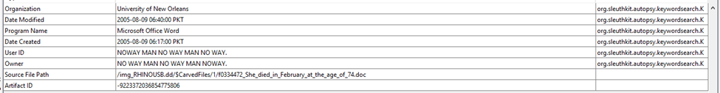  
  
The victim appeared to have been possessed the Rhino Pictures, as they were now emptying the hard drive into the Mississippi River. The reason why the hard drive was unavailable is now explicable. Notable as well is the fact that the USB would be formatted and certain **password change of gnome is discussed at Radio Shack which Jeremy provided.**

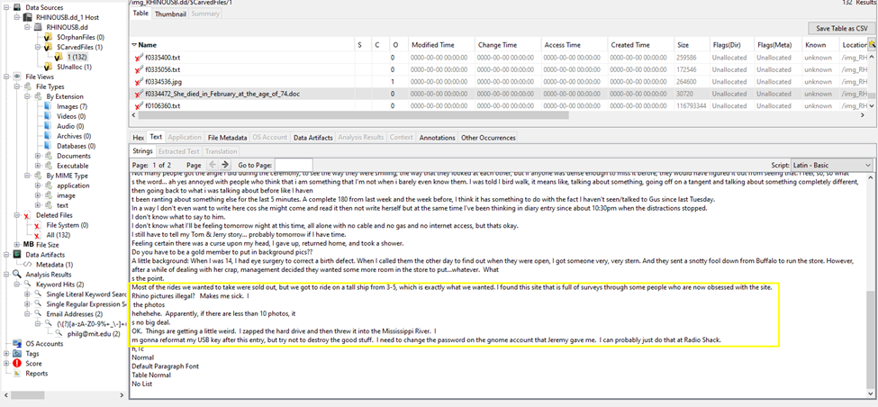

**Answer to Question 2: The username/password for the account is gnome/gnome123.**

Analysis of the log files is performed by **Wireshark**. Each log file's integrity has been examined by examining its hash. A filter of **ftp or ftp-data** has been implemented in order to observe FTP/telnet communications.  
  
***Rhino.log file Analysis:  
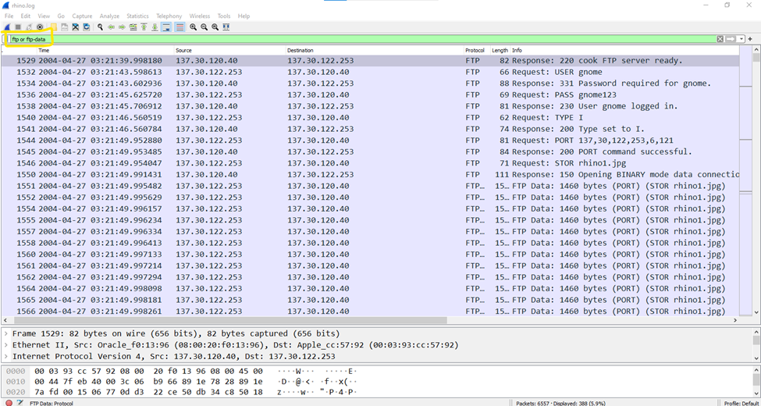***

  
  
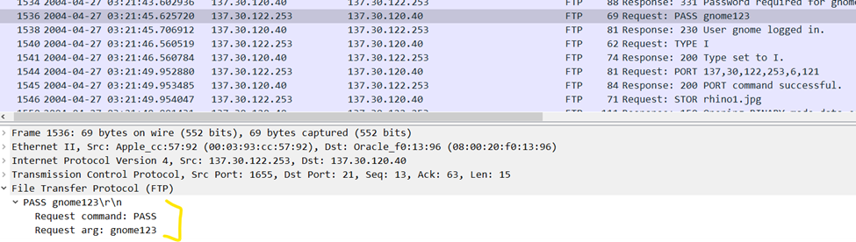  
Username is: gnome

The password is: gnome123

**Answer to Question 3: Relevant file transfers include several rhino images and an encrypted zip file, rhino.exe executable via HTTP.**

* rhino1.jpg, rhino3.jpg in rhino.log trace (FTP packets)
* rhino2.jpg in contraband.zip file from rhino.log file (encrypted zip file with password: monkey)
* rhino4.jpg, rhino5.gif in rhino2.log (HTTP)
* An executable “rhino.exe” in rhino3.log (HTTP)

The rhino images are now being traced out in the network  
  
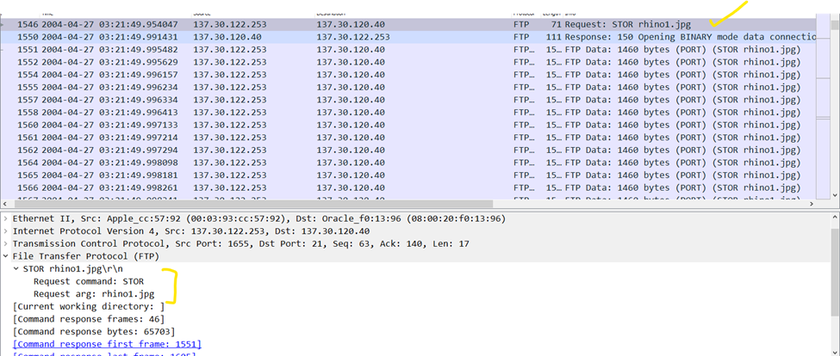  
These images would be recovered by **Follow->TCP Stream**  
  
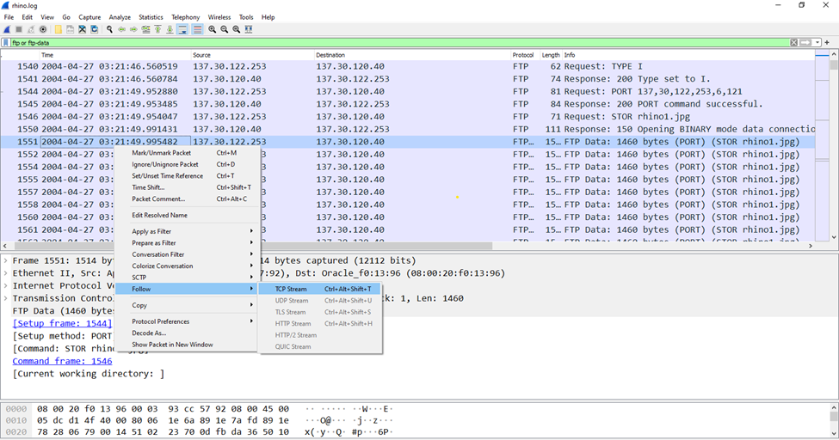  
  
  
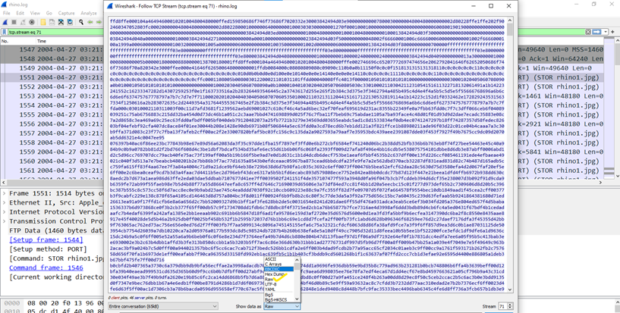  
  
The first Rhino Image is being saved as shown below:

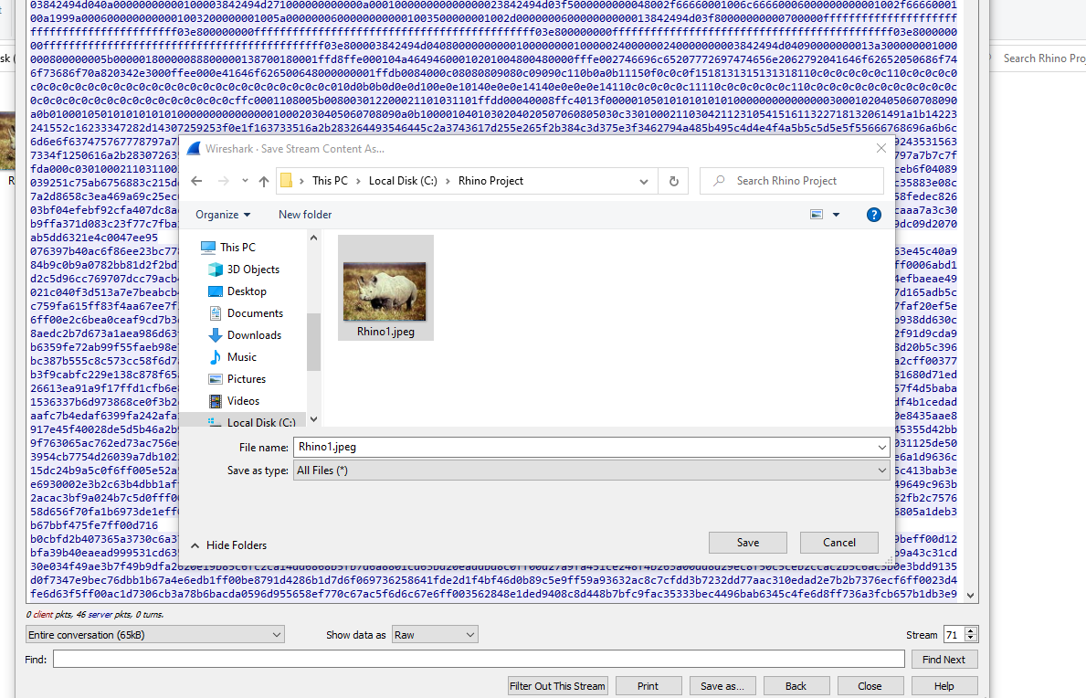  
  
The method described above was used to extract the remaining images. Rhino3.jpeg was extracted successfully.   
  
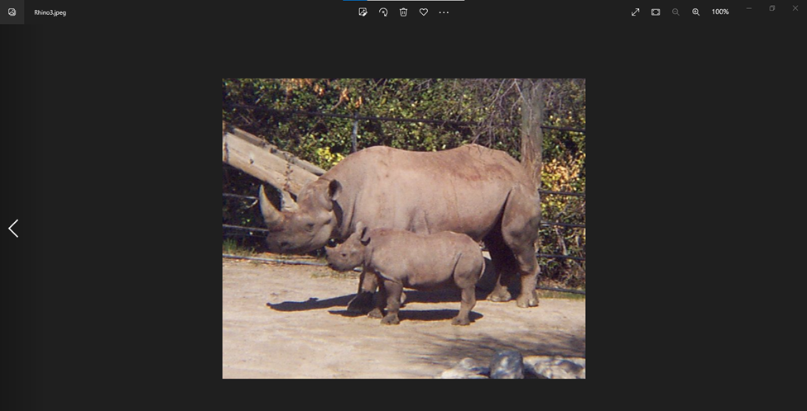  
Upon examining additional FTP transmissions, **contraband.zip file** was discovered, which is displayed below.  
  
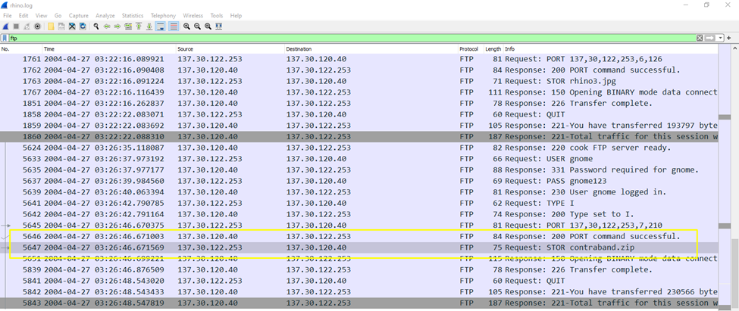  
  
**Answer to Question 4: The suspect disposed of the hard drive in the Mississippi River.  
  
**

**Answer to Question 5: The USB key was intended to be reformatted by the suspect.**Based on findings to questions 1 & 4, the suspect states that he will reformat the USB

I m gonna reformat my USB key after this entry, but try not to destroy the good stuff.” – source from f0334472_She_died_in_February_at_the_age_of_74.doc.  
  
  
  
This section of entirely carved files was a little dubious due to the fact that every.txt file contained SORRY and CHARLIE messages, and the alligator images were also annotated. This indicates that there must be some method of concealing objects; steganography may be a possibility. It will be dealt with subsequently.

**Answer to Question 6: Recoverable from the USB image were rhino and alligator pictures, a document detailing plans for the hardware, and recipe text files.**

* A document containing multiple responses concerning the suspect's intentions regarding the hard drive, USB, and the modification of the gnome password.
* Four Rhino pictures
* Some Alligator pictures
* And two recipe text files

The Autopsy utility includes a section for carved files.  
 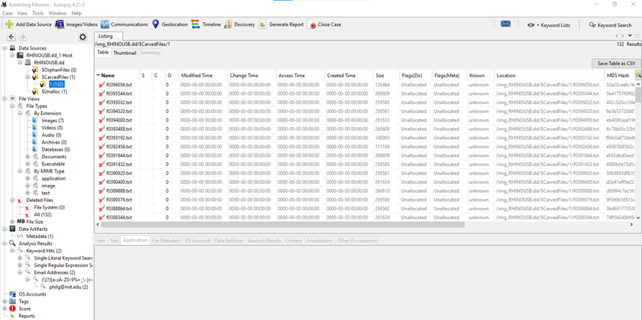  
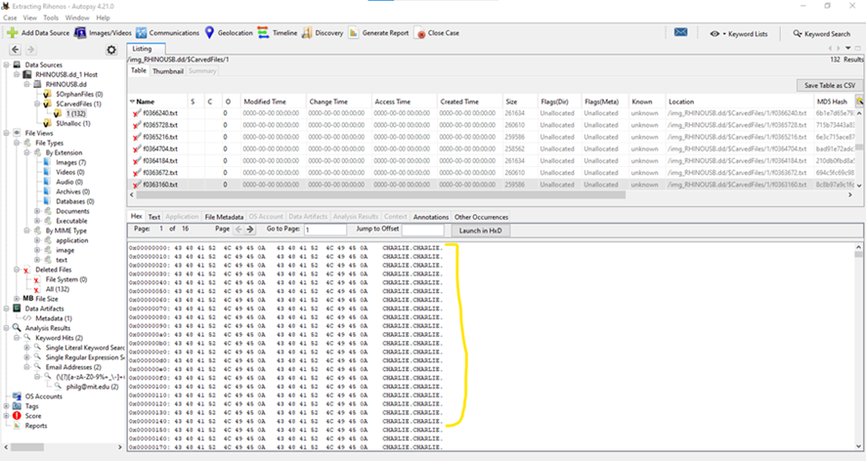  
  
**Text Files Filled with Repeated Text ("CHARLIE" and "SORRY")**:

* This might indicate an attempt to overwrite the original content of the text files, potentially as a method to obscure or destroy data that was previously stored. Overwriting data is a common technique used to make file recovery more difficult.
* The repeated use of specific words could also suggest steganography, where a message or other data could be hidden within the nonsense text. Steganography often requires further analysis since the hidden data might not be immediately apparent.
* It is also possible that these text patterns serve as a red herring, designed to distract from the actual valuable data or to consume the analyst's time with irrelevant information.

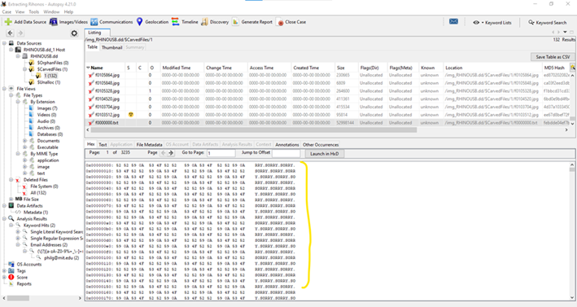  
  
**Rhino Pictures Identified in the Carved Files Section:**

* Carving files from a disk image can reveal deleted or otherwise hidden files. Discovering rhino pictures could be significant, especially if possessing such images is against the law or against specific regulations within a context, such as a corporate or educational setting.

These images would be of particular interest to the case, considering the legal implications detailed in the background provided. The recovery of these images supports the case against the suspect possessing these illegal files.  
  
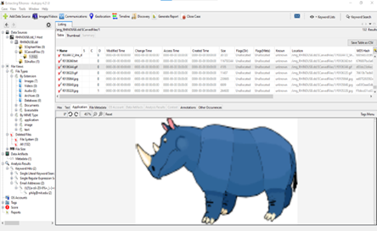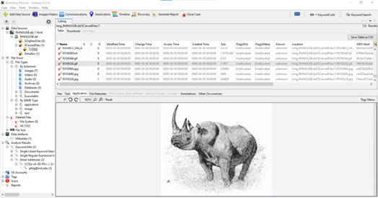  
  
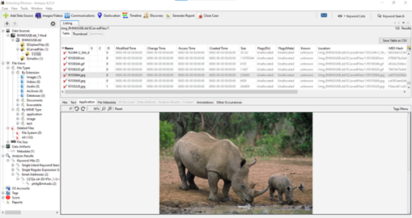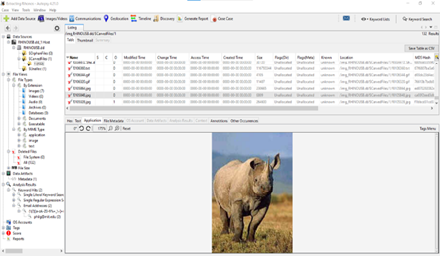  
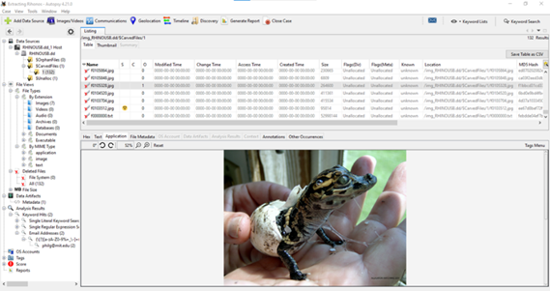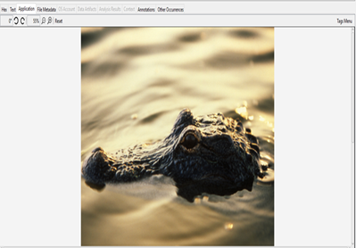  
  
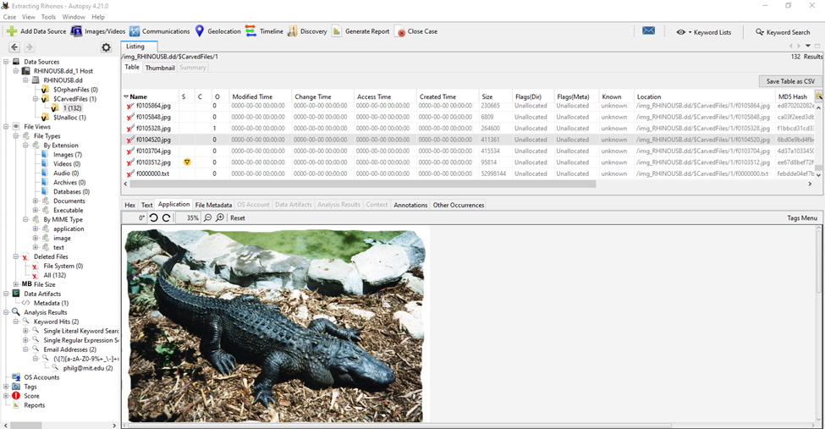  
  
**Answer to Question 7: Evidence connecting the USB key and network traces includes the presence of rhino2.jpg in both the USB image and the contraband encrypted zip file from the network trace.**

Upon examining additional FTP transmissions, a contraband.zip file was discovered, which is displayed below.  
  
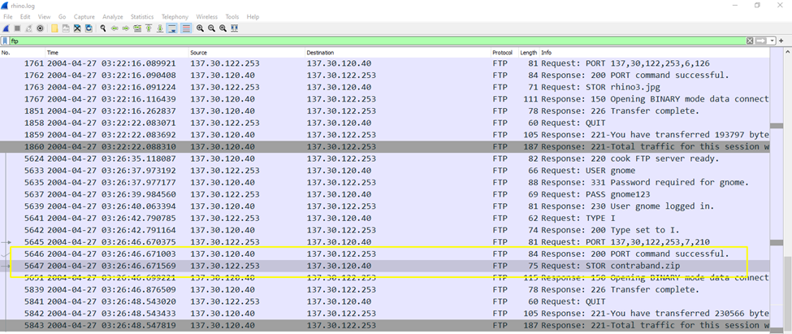  
  
  
**Extraction of contraband.zip:**

The file was saved after being extracted using Follow->tcp Stream.  
  
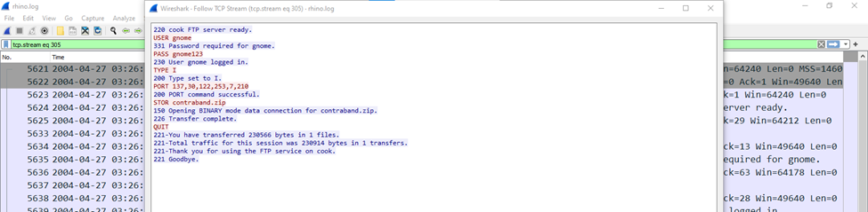  
  
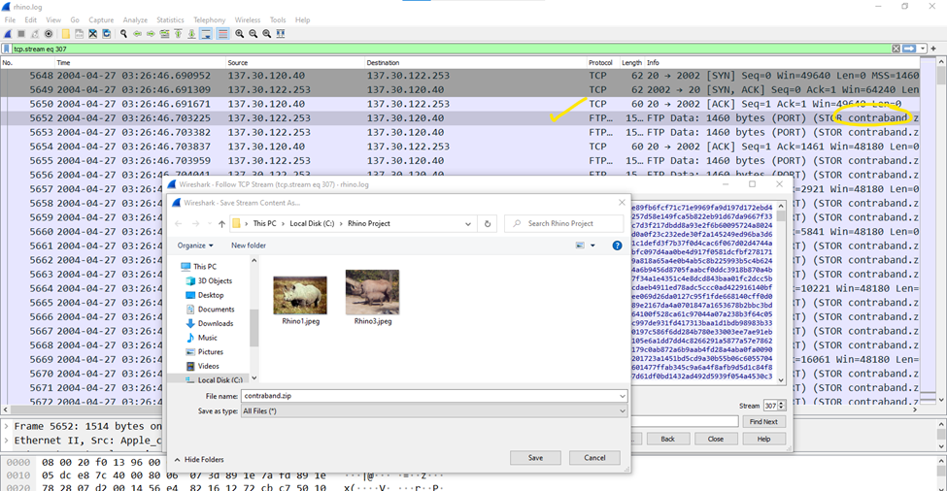  
  
All of this evidence has been transferred to a Kali Linux Machine. Attempting to extract the contraband.zip file reveals that it is **password protected**.  
  
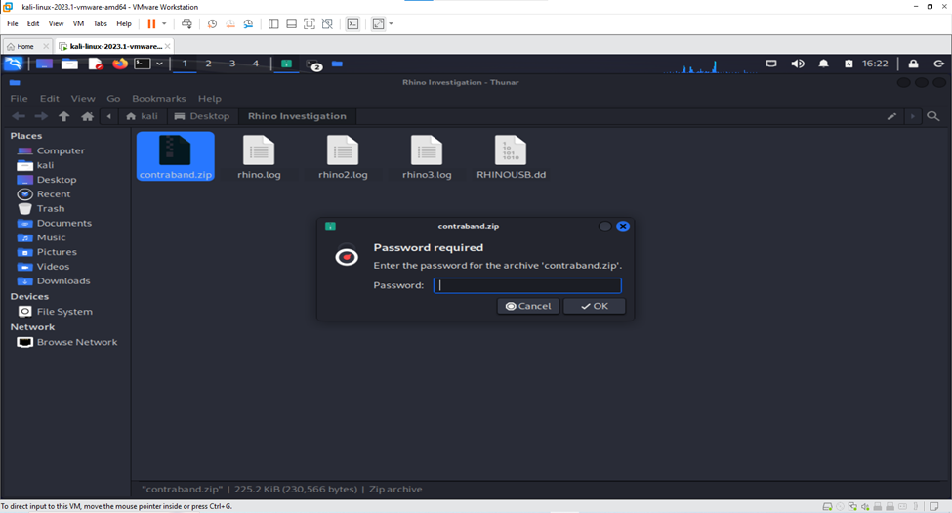  
  
  
  
The password for the zip file was successfully cracked by combining the rockyou.txt wordlist with fcrackzip.  
  
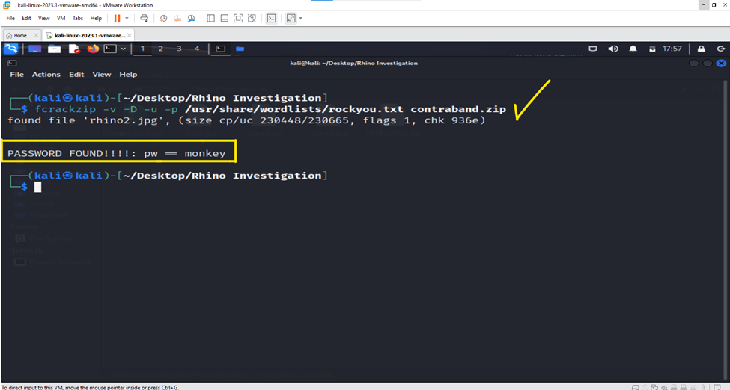  
  
Following the endeavor to find the monkey password, rhino2.jpeg was found.  
  
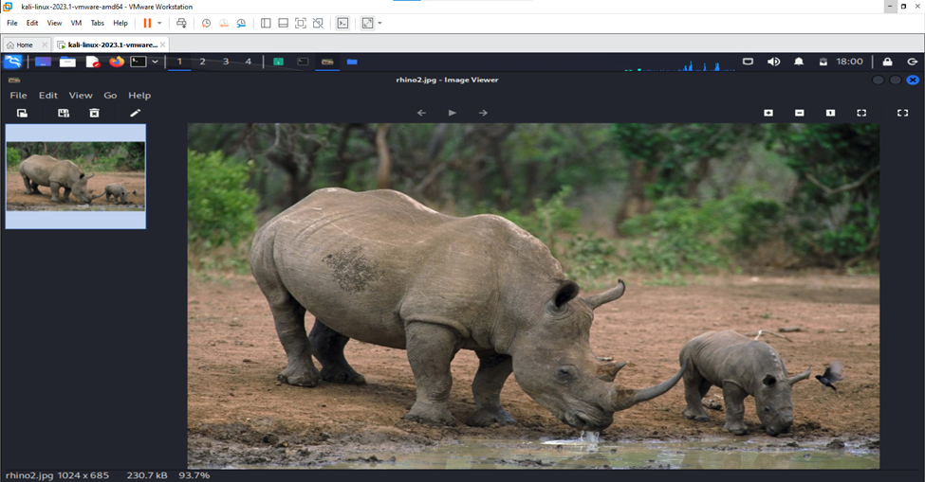  
  
  
***Rhino2.log File Analysis:***

The rhino4.jpg file that was requested in an HTTP Get packet has been located. Additional investigation is needed to find the picture.   
  
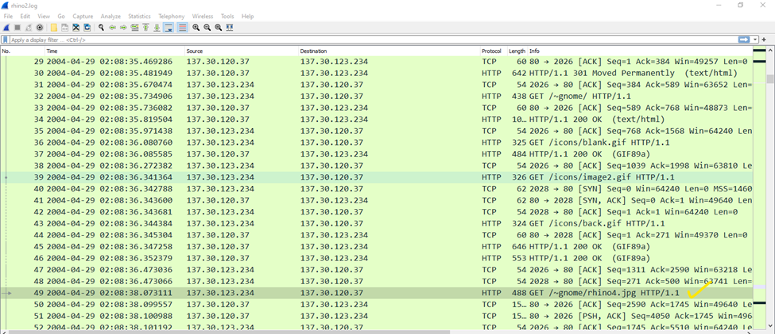  
  
**Image file rhino4.jpeg:**

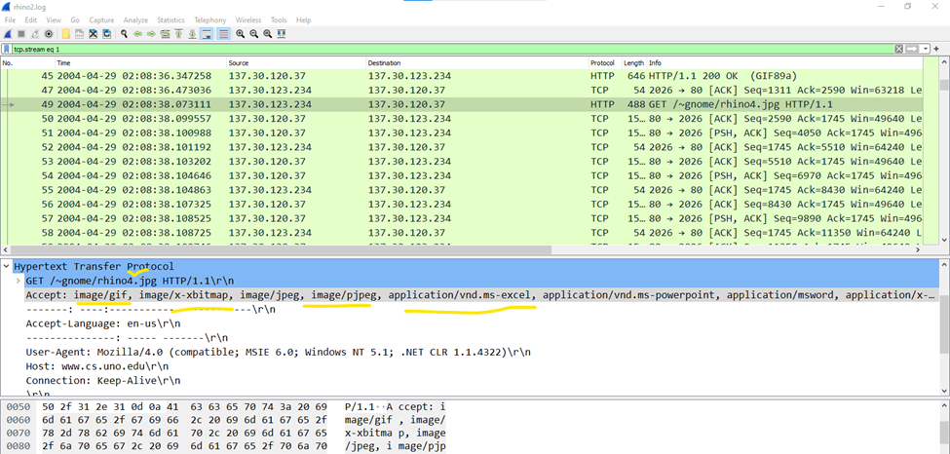

The image will be exported using >Export Objects>HTTP  
  
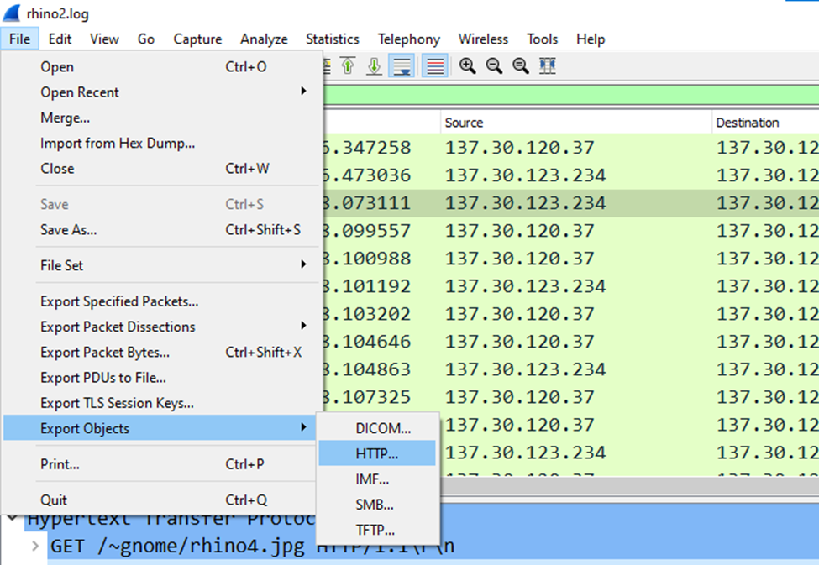  
  
  
There are additional images similar to **rhino5.jpeg**, as can be seen by examining the document.

Each image will be saved.  
  
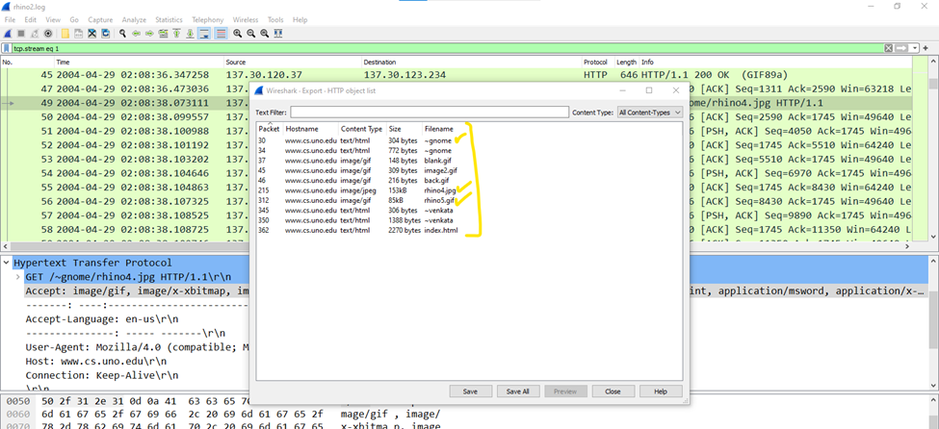  
  
  
  
**Rhino4.jpeg**

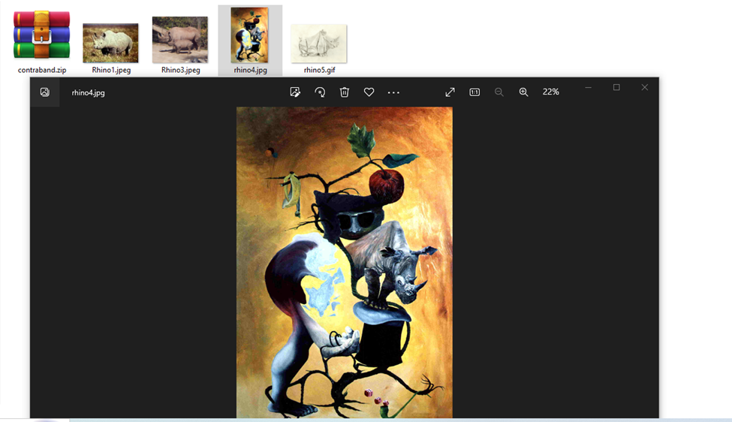  
  
**Rhino5.gif**

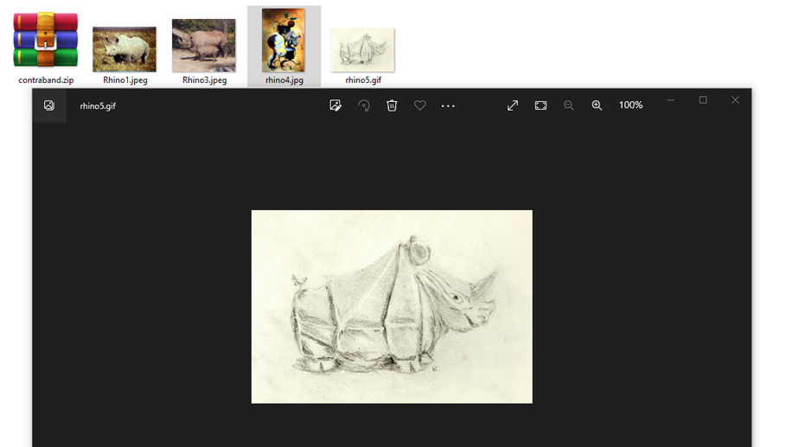  
  
  
  
  
**Rhino3.log Analysis:**

The rhino.exe file was located by expanding the file's TCP stream. However, further analysis will not be completed as additional search warrants will be needed, and it is outside the scope of the case.  
  
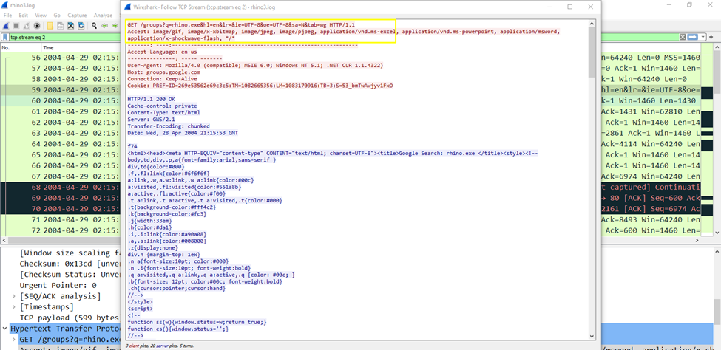

**Conclusion**

In conclusion, the data obtained from the USB image and network traces provides compelling indications that the suspect engaged in the unlawful possession and transfer of rhinoceros images in violation of New Orleans law by utilizing the FTP/telnet account and username "gnome" supplied by Jeremy. In addition, the suspect demonstrated an effort to conceal evidence by discarding the hard drive and indicating an intention to reformat the USB key. Additional inquiry may be justified into the suspicious activities, including the possible existence of steganography and encrypted files.

**Exhibits for Case FSIS-646-05-2023**

**Investigation Title:** New Orleans Rhino Image Trafficking  
**Lead Forensic Examiner:** Mohamed Elsayed  
**Date of Report:** 04/07/2024

**Exhibit A - Account Provision Details**

**Question 1:** Who gave the accused a telnet/ftp account?

**Findings:** The telnet/FTP account was provided by an individual identified as Jeremy. This was established through a document found within the carved files section of the analysis tool.

**Significance:** Identifying the person who provided the account credentials is crucial in understanding the suspect's network of contacts and possible accomplices in the illegal activity.  
  
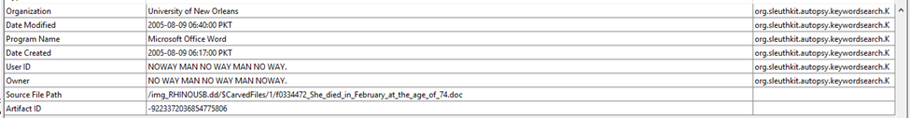  
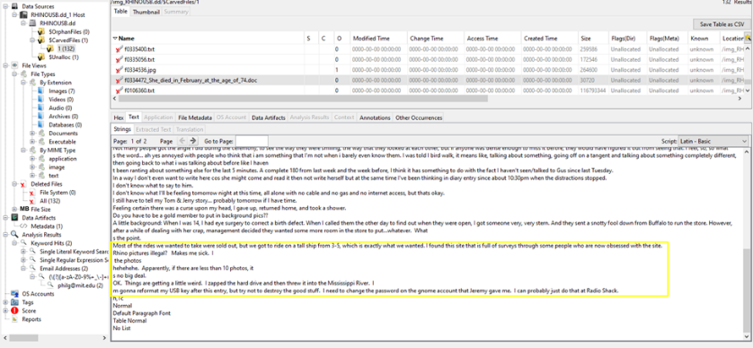

**Exhibit B - Account Credentials**

**Question 2:** What is the username/password for the account?

**Findings:** The username is "gnome," and the password is "gnome123," as revealed by the analysis of network logs using Wireshark.

**Significance:** The credentials were used to access the FTP server for the illegal transfer of rhinoceros images, directly implicating the suspect in the violation of the New Orleans law.  
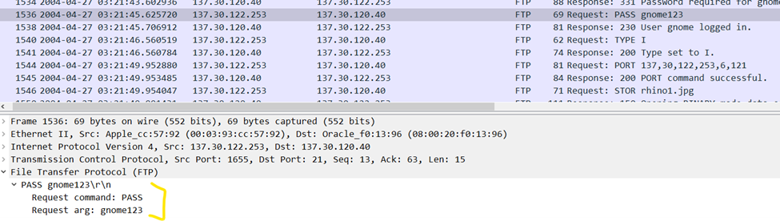

**Exhibit C - File Transfer Records**

**Question 3:** What relevant file transfers appear in the network traces?

**Findings:** Network logs indicated the transfer of files named rhino1.jpg, rhino3.jpg, rhino4.jpg, rhino5.gif, and an executable "rhino.exe," along with an encrypted zip file named contraband.zip.

**Significance:** These files represent the unlawful distribution and possession of rhinoceros images. The network traces provide a digital footprint of the suspect's actions.

|  |
| --- |
| rhino1.jpg, rhino3.jpg in rhino.log trace (FTP packets) |
| rhino2.jpg in contraband.zip file from rhino.log file (encrypted zip file with password: monkey) |
| rhino4.jpg, rhino5.gif in rhino2.log (HTTP) |
| An executable “rhino.exe” in rhino3.log (HTTP) |

**Exhibit D - Hard Drive Disposal**

**Question 4:** What happened to the hard drive on the computer? Where is it now?

**Findings:** The hard drive was intentionally disposed of in the Mississippi River, as indicated by a document found during the file carving process.

**Significance:** The disposal of the hard drive suggests an attempt to destroy evidence and hinder the forensic investigation.  
  


**Exhibit E - USB Key Intentions**

**Question 5:** What happened to the USB key?

**Findings:** There is a documented intention from the suspect to reformat the USB key, as mentioned in a document recovered from the USB drive image.

**Significance:** The suspect's plan to reformat the USB key is indicative of an effort to conceal or destroy digital evidence.  
  
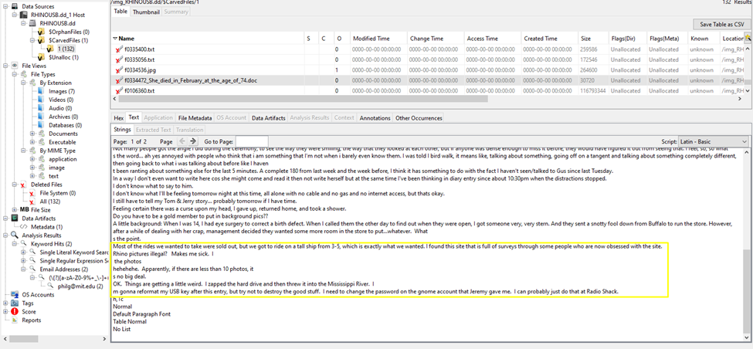

**Exhibit F - USB Image Recovery**

**Question 6:** What is recoverable from the image of the USB key?

**Findings:** The file carving process recovered rhinoceros and alligator images, documents detailing plans for the hardware, and recipe text files.

**Significance:** The recovery of multiple rhino images is central to proving the illegal possession of such images as stipulated by the law.

|  |
| --- |
| A document containing multiple responses concerning the suspect's intentions regarding the hard drive, USB, and the modification of the gnome password. |
| Four Rhino pictures |
| Some Alligator pictures |
| And two recipe text files |

**Exhibit G - Evidence Linking**

**Question 7:** Is there any evidence that connects the USB key and the network traces? If so, what?

**Findings:** The rhino2.jpg image was found both in the USB image and within the contraband.zip file from the network trace, establishing a connection between the physical evidence and network activity.

**Significance:** The presence of the same rhino image in both the USB drive and the network logs illustrates the transfer and possession of the illegal content by the suspect.

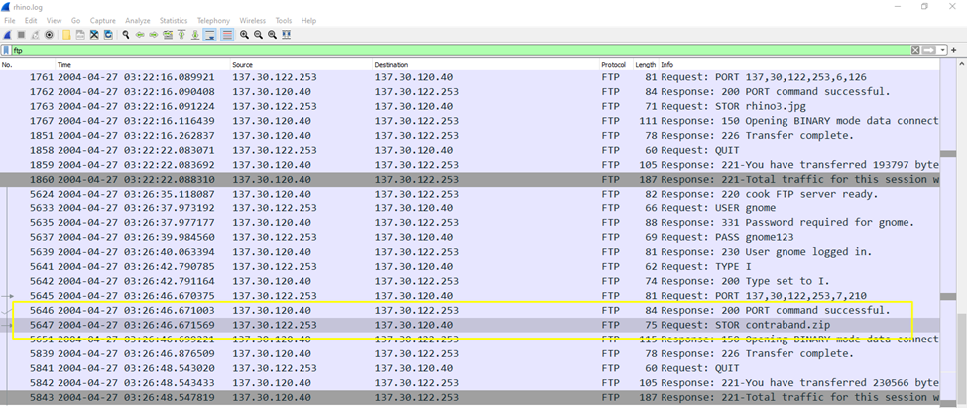

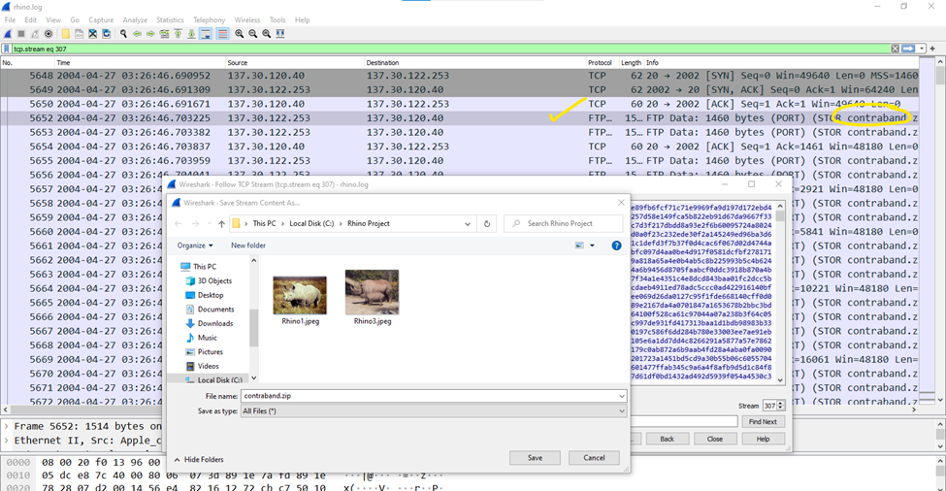

Mohamed Elsayed

Lead Computer Forensic Examiner